Smart Home

Name: Ahmed Mahmoud Mohamed Mahmoud

Department: Computer Engineering

Level: Three

ID: 4200601

Contents

* Introduction 4
* System Architecture 5
  1. Microcontroller 5
  2. Mechanical Switch 6
  3. LCD (lm016l) 7
  4. Servo motor 8
  5. DC motor 9
  6. Keypad 10
  7. Buzzer 11
* Communication protocols 12
  1. UART 12
  2. SPI 13
* System 14
  1. Architecture 14
  2. Flow Chart 15

**Introduction**

Welcome to the documentation for our Smart Home Project. This project aims to create an intelligent and interconnected living environment that enhances comfort, convenience, and energy efficiency. By leveraging modern technology, automation, and connectivity, our Smart Home Project offers a seamless integration of various devices and systems within your home.

The vision behind this project is to transform your house into a smart and responsive living space that adapts to your needs and preferences. With our system, you can control and monitor a wide range of devices and functions, including lighting, heating, security, entertainment, and more, all from a centralized interface or even remotely through your smartphone.

The primary goal of our Smart Home Project is to simplify your daily routines and enhance your quality of life. Imagine waking up to a gently lit bedroom, with your favorite music playing and the coffee machine starting automatically. As you leave for work, the system automatically adjusts the temperature, turns off unnecessary appliances, and ensures the house is secure. And when you return, the house welcomes you with a comfortable ambiance, pre-set lighting, and your preferred temperature.

In this documentation, we will provide a comprehensive guide on setting up, configuring, and utilizing the various components of our Smart Home Project. We will explain how to integrate different devices, program automation routines, and customize settings according to your preferences. Additionally, we will address security and privacy considerations to ensure your peace of mind.

Whether you're a tech enthusiast, a busy professional, or someone who values convenience and efficiency, our Smart Home Project has something to offer for everyone. We hope this documentation helps you understand and maximize the potential of our system, making your home smarter, more connected, and ultimately more enjoyable.

Please refer to the following sections for detailed instructions, troubleshooting guides, and further information on specific aspects of the Smart Home Project. If you have any questions or require assistance, our support team is readily available to help you on your smart home journey.

Let's embark on this exciting journey of transforming your home into a truly intelligent and responsive space with our Smart Home Project!

**System Architecture**

1. **Smart Devices:**
   1. Microcontroller:

* Architecture: The ATmega32 is based on the Harvard architecture and employs an 8-bit RISC (Reduced Instruction Set Computer) CPU core. It operates at a clock frequency of up to 16 MHz and supports both 8-bit and 16-bit arithmetic operations.
* Memory: The ATmega32 has 32 kilobytes (KB) of flash memory, which is used for storing the program instructions (firmware). It also has 2 KB of static random-access memory (SRAM) for data storage during runtime. Additionally, it includes 1 KB of electrically erasable programmable read-only memory (EEPROM) for non-volatile data storage.
* Peripherals: The microcontroller features various built-in peripherals, including digital and analog input/output (I/O) pins. It has a total of 32 I/O pins, which can be individually configured as inputs or outputs. These pins can be used for connecting to sensors, actuators, display modules, and other external devices.
* Communication Interfaces: The ATmega32 supports popular communication protocols such as UART (Universal Asynchronous Receiver/Transmitter), SPI (Serial Peripheral Interface), and I2C (Inter-Integrated Circuit). These interfaces enable the microcontroller to communicate with other devices, including sensors, displays, memory chips, and wireless modules.
* Timers and Counters: It includes three 16-bit timers/counters and one 8-bit timer/counter. These timers can be used for tasks such as generating precise timing intervals, measuring external events, or generating PWM (Pulse Width Modulation) signals for controlling motor speed or LED brightness.
* Interrupt System: The ATmega32 has an advanced interrupt system with multiple interrupt sources. It allows the microcontroller to respond quickly to external events or time-critical tasks, enabling efficient handling of real-time requirements.
* Power Management: The microcontroller incorporates power-saving features, including sleep modes and power-down modes, to optimize energy consumption and extend battery life in low-power applications.
* Development Tools: The ATmega32 is supported by a range of development tools, including Atmel Studio (an integrated development environment), compilers, debuggers, and in-system programmers. These tools facilitate firmware development, debugging, and programming onto the microcontroller.
  1. Mechanical Switch:
* Construction: Mechanical switches consist of movable contacts that can be physically opened or closed to control the flow of electricity. They typically include a housing or body, contacts, and an actuator mechanism. The contacts are made of conductive materials, such as metal, that come into contact or separate from each other to complete or break the circuit.
* Types of Mechanical Switches: There are various types of mechanical switches, including:
  + Push-button switches: These switches require manual pressing of a button or actuator to open or close the contacts. They can be momentary (spring-loaded, returning to their original position when released) or latching (remaining in the pressed or unpressed position until manually changed).
  + Toggle switches: These switches have a lever or toggle mechanism that can be flipped up or down to open or close the contacts. They typically maintain their state until manually toggled to the opposite position.
  + Rotary switches: These switches have a rotating mechanism, often in the form of a knob or dial, that can be turned to select different positions or options.
  + Slide switches: These switches have a sliding mechanism that can be moved along a track to open or close the contacts.
  + Rocker switches: These switches have a rocking mechanism that can be tilted on one side or the other to open or close the contacts.
* Functionality: When a mechanical switch is closed (contacts touching), it allows the electric current to flow through the circuit, completing the electrical path. When the switch is open (contacts separated), it interrupts the current flow, breaking the circuit. The actuation force required to open or close the switch depends on the design and construction of the switch.
* Applications: Mechanical switches find applications in a wide range of devices and systems, including home appliances, industrial machinery, automotive controls, computer keyboards, gaming controllers, and many more. They are often used for basic on/off control, mode selection, circuit routing, or as user input devices.
* Durability and Reliability: Mechanical switches are known for their durability and reliability, capable of enduring numerous actuations over their lifetime. They can withstand mechanical stress, vibrations, and environmental conditions, making them suitable for both indoor and outdoor applications.
* Limitations: While mechanical switches are robust, they have certain limitations. They may experience wear and tear over time due to physical contact, resulting in contact degradation or failure. Additionally, mechanical switches may produce a tactile feedback or audible click when actuated, which can be desirable or undesirable depending on the application.
  1. LCD (lm016l):
* Display Type: The LM016L is a 16x2 character LCD, meaning it can display 16 columns and 2 rows of characters. Each character position can display a single alphanumeric character, symbol, or custom-defined character.
* Display Technology: The LM016L utilizes a liquid crystal display technology, which consists of a layer of liquid crystals sandwiched between two polarized glass plates. When an electric field is applied, the liquid crystals align to control the passage of light, resulting in the display of characters.
* Character Set: The LM016L supports a standard set of ASCII characters, including uppercase letters (A-Z), lowercase letters (a-z), digits (0-9), symbols, and control characters. It can display a wide range of characters, allowing for basic text-based information display.
* Interface: The LM016L typically uses a parallel interface to communicate with a microcontroller or other controlling devices. It requires multiple data lines, control signals (such as register select, read/write, and enable), and a contrast adjustment for proper operation. The specific pin configuration may vary depending on the manufacturer and model.
* Backlight: The LM016L LCD module often includes a built-in LED backlight for improved visibility in low-light conditions. The backlight can be controlled separately from the characters, allowing the user to adjust the contrast and brightness.
* Power Supply: The LM016L requires a power supply voltage (typically 5V) and a contrast voltage to ensure proper operation. It usually includes power-saving features that allow the module to enter a low-power state when not in use.
* Applications: The LM016L LCD module finds applications in a wide range of devices that require basic text-based information display. It is commonly used in consumer electronics, appliances, measurement instruments, industrial control panels, and various embedded systems.
  1. Servo motor:
* Working Principle: Servo motors operate based on feedback control. They consist of a DC motor, a position-sensing device (such as a potentiometer or an encoder), and a control circuit. The control circuit continuously compares the actual position of the motor shaft with the desired position and adjusts the motor's rotation accordingly.
* Control Signal: Servo motors are typically controlled by sending a pulse width modulation (PWM) signal. The control signal, often referred to as a servo signal, consists of a series of pulses with a specific width. The width of the pulses determines the desired position or angle of the servo motor shaft.
* Rotation Range: Servo motors have a limited rotation range, usually between 0 and 180 degrees, although some models can provide continuous rotation. The position control allows the motor to accurately move to a desired position within its specified range.
* Torque and Speed: Servo motors provide relatively high torque for their size, allowing them to exert precise control over the motion of connected mechanisms. The speed of the servo motor depends on the applied voltage and the load it is driving. Servo motors are designed to offer quick response and precise movement.
* Feedback and Closed-Loop Control: The position-sensing device (potentiometer or encoder) in the servo motor provides feedback to the control circuit, enabling closed-loop control. The feedback mechanism allows the control circuit to continually adjust the motor's rotation until the desired position is reached, ensuring accuracy and stability.
* Servo Control Mechanisms: Servo motors can be controlled using different mechanisms. The most common types are positional control (moving the motor to a specific position), continuous rotation control (setting the speed and direction of rotation), and proportional control (controlling the motor's position based on the input signal's magnitude).
* Applications: Servo motors find widespread use in robotics, industrial automation, model aircraft and vehicle control, camera gimbals, CNC machines, 3D printers, and various other systems that require precise and controlled motion.
* Power Supply: Servo motors typically require a separate power supply, which is usually a DC voltage in the range of 4.8V to 7.2V, depending on the specific servo motor model. The power supply voltage should match the servo motor's specifications to ensure proper operation.
  1. DC motor:
* Construction: DC motors consist of a stationary part called the stator and a rotating part called the rotor. The stator contains magnets or coils, while the rotor consists of a shaft and a set of coils or permanent magnets. The interaction between the stator and rotor creates a magnetic field that generates the rotational motion.
* Working Principle: When an electric current is supplied to the motor, it creates a magnetic field in the stator. The magnetic field interacts with the magnetic field of the rotor, resulting in a torque that causes the rotor to rotate. The direction of rotation depends on the polarity of the current and the arrangement of the magnets or coils.
* Commutation: DC motors require a method of switching the direction of the current in the rotor coils as the rotor rotates. This process is called commutation and is typically achieved using brushes and a commutator or through electronic commutation in brushless DC motors.
* Speed Control: The speed of a DC motor can be controlled by adjusting the voltage applied to the motor. By increasing or decreasing the voltage, the speed can be varied. Additionally, speed control can be achieved by using pulse width modulation (PWM) techniques, which involve rapidly switching the motor on and off.
* Torque and Speed Characteristics: DC motors can provide high torque, especially at low speeds. The torque-speed characteristics of a DC motor can be influenced by factors such as the voltage applied, the motor design, and the load on the motor.
* Applications: DC motors find wide applications in various fields, including robotics, industrial machinery, electric vehicles, consumer electronics, and more. They are used in fans, pumps, conveyor systems, electric vehicles, drones, toys, and other devices that require rotational motion.
* Power Supply: DC motors require a DC power supply, typically provided by batteries, power supplies, or motor controllers. The voltage and current requirements of the motor should match the specifications provided by the manufacturer.
* Control and Protection: DC motors can be controlled using motor drivers or controllers that regulate the current, voltage, and direction of rotation. Additionally, protective measures such as overcurrent protection and thermal protection can be implemented to ensure safe and reliable operation.
  1. Keypad (7-pins):
* Button Layout: A 7-pin keypad is designed with a grid of buttons. The most common configuration is a 4x3 matrix, which consists of 12 buttons organized into four rows and three columns. Another variation is the 4x4 matrix, which includes 16 buttons. Each button represents a specific character, digit, or command.
* Electrical Connections: The 7-pin keypad utilizes a matrix arrangement to connect the buttons to the controlling device. The rows and columns of buttons are connected to the pins of the keypad. The rows are usually connected to output pins, while the columns are connected to input pins.
* Matrix Scanning: The scanning process involves sequentially activating the keypad's rows and columns to determine which button is pressed. By selectively activating one row at a time while monitoring the state of the columns, the controller can identify the button pressed based on the row and column combination.
* Pin Configuration: A typical 7-pin keypad consists of seven connection pins. Four pins are used for the rows (R1, R2, R3, and R4), and three pins are used for the columns (C1, C2, and C3). The pins are numbered or labeled accordingly, and their connections may vary depending on the manufacturer or model.
* Interface: The keypad is typically connected to a microcontroller or other controlling device using digital input/output (I/O) pins. The rows and columns of the keypad are connected to the corresponding I/O pins of the controller, allowing it to read the button presses and interpret them as input data.
* Button Press Detection: When a button is pressed on the keypad, the corresponding row and column make electrical contact, resulting in a change in voltage or logic level at the respective pins. The controlling device scans the rows and columns to detect these changes and determine the pressed button.
* Applications: 7-pin keypads are commonly used in various applications that require user input, such as security systems, access control panels, calculators, electronic locks, appliances, and embedded systems. They provide a convenient and cost-effective solution for data entry and menu navigation.
* Programming: To utilize a 7-pin keypad, the controlling device needs to implement the scanning algorithm to detect button presses and interpret the resulting row-column combinations. This process involves configuring the input/output pins, reading the keypad matrix, and mapping the button presses to their corresponding actions or characters.
  1. Buzzer:
* Function: The primary function of a buzzer is to generate sound or an audible tone when activated. It converts electrical energy into mechanical vibrations that produce sound waves.
* Construction: A buzzer typically consists of a housing, a piezoelectric or electromagnetic transducer, and a diaphragm. The transducer is responsible for converting the electrical signal into mechanical vibrations, while the diaphragm amplifies and projects the sound waves.
* Operating Principle:
* Piezoelectric Buzzer: Piezoelectric buzzers use a piezoelectric crystal or ceramic material that deforms when an electric voltage is applied, generating mechanical vibrations and producing sound waves.
* Electromagnetic Buzzer: Electromagnetic buzzers utilize an electromagnet and a diaphragm. When an electric current passes through the electromagnet, it creates a magnetic field that attracts or repels the diaphragm, causing it to vibrate and generate sound.
* Sound Output: Buzzers can produce different types of sounds, including continuous tones, intermittent tones, beeps, or melodies, depending on their design and input signals. The sound output is determined by the frequency and amplitude of the electrical signal applied to the buzzer.
* Control and Activation: Buzzers are activated by applying an electric current or voltage to the appropriate terminals or pins. The control signal, typically generated by a microcontroller or other controlling devices, determines the frequency and duration of the sound produced.
* Power Supply: Buzzers generally operate on low voltages, typically ranging from a few volts to around 12 volts. The voltage and current requirements vary depending on the specific buzzer model and design.
* Applications: Buzzers find applications in various fields, including alarm systems, electronic devices, appliances, automotive systems, medical equipment, security systems, and more. They provide auditory feedback, warnings, or signals to indicate specific events or conditions.
* Programming: To utilize a buzzer, the controlling device (e.g., microcontroller) generates the appropriate electrical signal to activate the buzzer. This can involve configuring output pins, specifying the sound frequency and duration, and synchronizing the buzzer activation with the desired system events or conditions.

1. **Communication protocols**

**UART:**

* Communication Protocol: UART is an asynchronous communication protocol, meaning it does not require a separate clock signal to synchronize data transmission between devices. Instead, it uses a fixed baud rate, which determines the speed of data transfer.
* Data Transmission: UART transmits data in a sequential manner, one bit at a time, over a single communication line. The data is sent as a series of binary bits, typically 8 bits per data byte. However, UART can be configured for different data lengths, such as 7 or 9 bits.
* Start and Stop Bits: UART uses start and stop bits to frame the data byte. The start bit indicates the beginning of a data byte, while the stop bit(s) signal the end of the byte. The start bit is always low (0), and the stop bit(s) is high (1). The number of stop bits can be configured, usually 1 or 2.
* Baud Rate: The baud rate determines the speed of data transmission in bits per second (bps). Both the transmitting and receiving devices must be configured to use the same baud rate to ensure proper communication. Common baud rates include 9600, 19200, 115200, and higher.
* Serial Data Format: UART serial data is typically transmitted in a least significant bit (LSB) first format, where the least significant bit is sent first, followed by the more significant bits. However, some devices or systems may use a most significant bit (MSB) first format.
* Duplex: UART communication is typically half-duplex, meaning data can be transmitted in only one direction at a time. However, full-duplex communication can be achieved by using two separate UART channels, one for transmitting and the other for receiving.
* Hardware and Software Implementation: UART can be implemented using dedicated hardware modules or through software-based UART implementations on microcontrollers or other programmable devices. Hardware UART modules provide dedicated circuitry for data transmission and reception, while software UART implementations utilize GPIO pins and software routines to emulate the functionality.
* Applications: UART is widely used for serial communication in various applications, including serial interfaces between microcontrollers, communication with sensors and modules (e.g., GPS modules, Bluetooth modules), computer peripherals (e.g., UART-based serial ports), and inter-chip communication in embedded systems.

**SPI:**

* Communication Architecture: SPI operates in a master-slave architecture, where one device acts as the master and initiates the data transfer, while one or more devices act as slaves and respond to the master's commands or requests.
* Serial Data Lines: SPI uses four primary lines for communication:
* SCLK (Serial Clock): The master generates clock pulses on the SCLK line, synchronizing data transfer between the master and the slave(s).
  + MOSI (Master Out Slave In): The master sends data to the slave(s) on the MOSI line.
  + MISO (Master In Slave Out): The slave(s) send data back to the master on the MISO line.
  + SS (Slave Select): The SS line is used by the master to select the specific slave device with which it wishes to communicate.
* Data Transfer: SPI transfers data in full-duplex mode, allowing simultaneous transmission and reception of data between the master and the slave(s). The master initiates data transfer by sending clock pulses on the SCLK line while sending data bits on the MOSI line. The slave(s) receive the clock pulses and data bits on the MISO line and respond accordingly.
* Data Frame Format: SPI uses a configurable data frame format, typically 8 bits in length. However, the data frame length can be adjusted to 9, 10, 16, or other desired sizes in certain implementations. The data frame is transmitted and received in a specified order, often most significant bit (MSB) first or least significant bit (LSB) first.
* Clock Polarity and Phase: SPI provides flexibility in clock polarity (CPOL) and clock phase (CPHA) configurations. The CPOL determines the idle state of the SCLK line (high or low), while the CPHA determines the edge on which data is sampled and shifted. These configurations allow compatibility with various SPI devices that may have different requirements.
* Speed and Data Rate: SPI can support high-speed data transfer depending on the capabilities of the devices involved. The data rate is determined by the clock frequency and the number of clock cycles required for each data transfer. Clock frequencies can range from a few kilohertz to several megahertz.
* Chip Select: The master device selects a specific slave device for communication using the SS (Slave Select) line. The master activates the SS line of the desired slave device before initiating data transfer. This allows multiple slave devices to share the same SPI bus, and the master can selectively communicate with individual slaves by activating their respective SS lines.
* Applications: SPI is commonly used in various applications, including communication between microcontrollers and peripherals (such as sensors, displays, memory chips), configuration and programming of integrated circuits, inter-chip communication, and data exchange between embedded systems.

1. **System**
   1. **Architecture:**

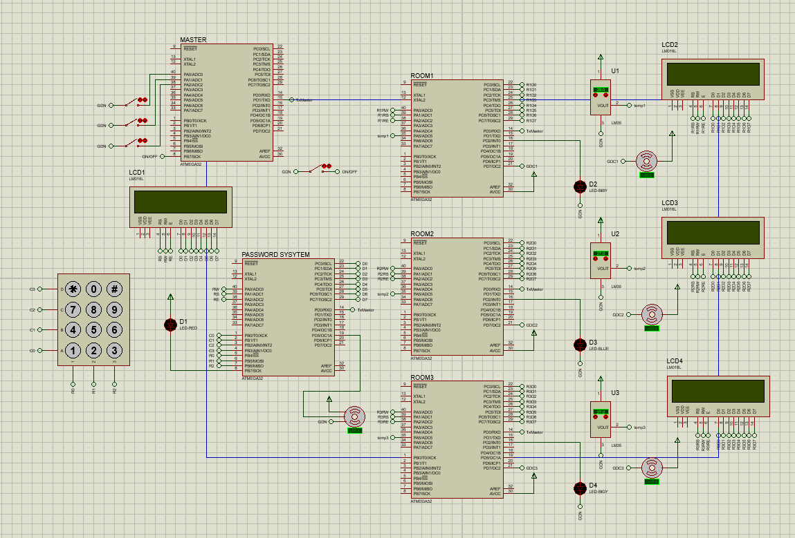

* 1. **Flow chart**

